**Your Task:** Your task is to use the function on any dataset you want or the dataset given

by me in the link above and prepare a report on what results you are getting and how this

function worked.

To

Rishabh Goyal,

From

Pampana Jai Kiran.

Sir, I have successfully completed the task 4.

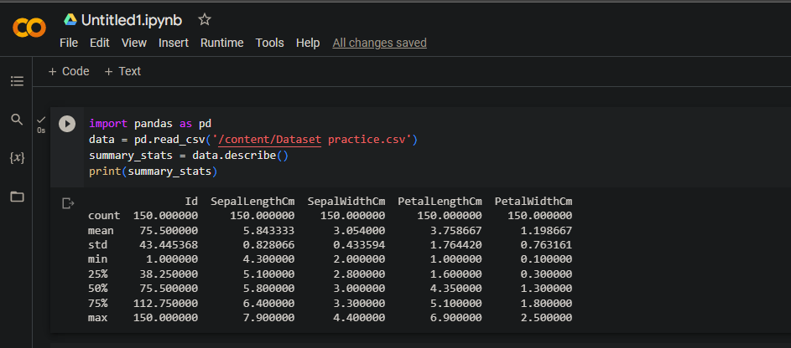

After using Describe function() in the Practice.csv. The generates summary statistics for each numeric column in the dataset.

The statistics include:

Id SepalLengthCm SepalWidthCm PetalLengthCm PetalWidthCm

count 150.000000 150.000000 150.000000 150.000000 150.000000

mean 75.500000 5.843333 3.054000 3.758667 1.198667

std 43.445368 0.828066 0.433594 1.764420 0.763161

min 1.000000 4.300000 2.000000 1.000000 0.100000

25% 38.250000 5.100000 2.800000 1.600000 0.300000

50% 75.500000 5.800000 3.000000 4.350000 1.300000

75% 112.750000 6.400000 3.300000 5.100000 1.800000

max 150.000000 7.900000 4.400000 6.900000 2.500000

Here's an analysis of the dataset statistics:

Count: There are 150 data points in this dataset, meaning there are 150 observations or rows.

Mean (Average): These values represent the average values for each attribute:

Sepal Length: 5.843333

Sepal Width: 3.054000

Petal Length: 3.758667

Petal Width: 1.198667

Standard Deviation (Std): These values give you a measure of how spread out the data is from the mean:

Sepal Length: 0.828066

Sepal Width: 0.433594

Petal Length: 1.764420

Petal Width: 0.763161

Minimum (Min): These values are the smallest observed values for each attribute:

Sepal Length: 4.3

Sepal Width: 2.0

Petal Length: 1.0

Petal Width: 0.1

25th Percentile (Q1): This represents the 25th percentile or the lower quartile, indicating the value below which 25% of the data falls:

Sepal Length: 5.1

Sepal Width: 2.8

Petal Length: 1.6

Petal Width: 0.3

50th Percentile (Median): This is the middle value of the dataset when arranged in ascending order (also known as the median):

Sepal Length: 5.8

Sepal Width: 3.0

Petal Length: 4.35

Petal Width: 1.3

75th Percentile (Q3): This represents the 75th percentile or the upper quartile, indicating the value below which 75% of the data falls:

Sepal Length: 6.4

Sepal Width: 3.3

Petal Length: 5.1

Petal Width: 1.8

Maximum (Max): These values are the largest observed values for each attribute:

Sepal Length: 7.9

Sepal Width: 4.4

Petal Length: 6.9

Petal Width: 2.5

These statistics provide a good overview of the central tendency, spread, and distribution of the data for each attribute. They are useful for understanding the characteristics of the dataset and can be used for further analysis or visualization.